NODEAPI GET ,POST,PUT & DELETE REQUESTS:

Contents

***Routing:*** 1

***Route paths*** 1

***app.get() Function:*** 2

Code: 2

Output 2

***app.post() Function*** 3

*Code:* 4

Output: 4

***app.put() Function:*** 5

***Code:*** 6

*Output:* 6

***app.delete() Function:*** 6

*Code* 7

*Output:* 7

# ***Routing:***

**Routing** refers to how an application’s endpoints (URIs) respond to client requests. For an introduction to routing, see [Basic routing](https://expressjs.com/en/starter/basic-routing.html).

You define routing using methods of the Express app object that correspond to HTTP methods; for example, app.get() to handle GET requests and app.post to handle POST requests. For a full list, see [app.METHOD](https://expressjs.com/en/4x/api.html" \l "app.METHOD). You can also use [app.all()](https://expressjs.com/en/4x/api.html" \l "app.all) to handle all HTTP methods and [app.use()](https://expressjs.com/en/4x/api.html" \l "app.use) to specify middleware as the callback function (See [Using middleware](https://expressjs.com/en/guide/using-middleware.html) for details).

# ***Route paths***

Route paths, in combination with a request method, define the endpoints at which requests can be made. Route paths can be strings, string patterns, or regular expressions.

Check for more info : <https://expressjs.com/en/guide/routing.html>

This route path will match requests to / newsletter.

# ***app.get() Function:***

The **app.get()** function returns the value *name* app setting.

The **app.set()** function is used to assigns the setting name to value. This function is used to get that values which are assigned.

**Syntax:**

app.get(name)

**Installation of express module:**

1. You can visit the link to [Install express module](https://www.npmjs.com/package/express). You can install this package by using this command.

npm install express

1. After that, you can just create a folder and add a file for example, index.js. To run this file you need to run the following command.

node server.js

*More info:* [*https://www.geeksforgeeks.org/express-js-app-get-function/*](https://www.geeksforgeeks.org/express-js-app-get-function/)

## Code:

app.get('/newsletter', function (req, res) {

  res.json(  //it will send the json

    [{

      "newsLetterParagraph": "Design is not just what it looks like and feels like. Design is how it works.",

    }]

  )

});

Output:

GET: http://localhost:3000/newsletter

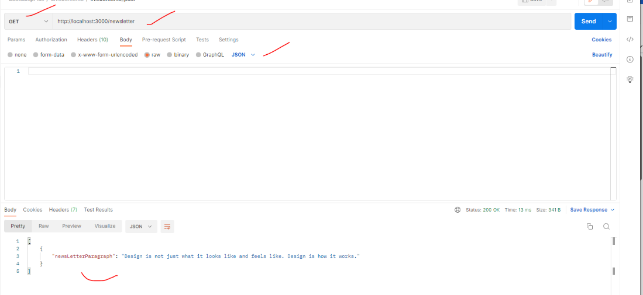

# ***app.post() Function***

*The****app.post() function****routes the HTTP POST requests to the specified path with the specified callback functions.*

***Syntax:***

*app.post(path, callback [, callback ...])*

***Arguments:***

1. ***Path:****The path for which the middleware function is invoked and can be any of:*
   * *A string representing a path.*
   * *A path pattern.*
   * *A regular expression pattern to match paths.*
   * *An array of combinations of any of the above.*
2. ***Callback:****Callback functions can be:*
   * *A middleware function.*
   * *A series of middleware functions (separated by commas).*
   * *An array of middleware functions.*
   * *A combination of all of the above.*

***Installation of express module:***

1. *You can visit the link to*[*Install express module*](https://www.npmjs.com/package/express)*. You can install this package by using this command.*

*npm install express*

1. *After that, you can just create a folder and add a file for example, index.js. To run this file you need to run the following command.*

*node server.js*

*More Info:* [*https://www.geeksforgeeks.org/express-js-app-post-function/*](https://www.geeksforgeeks.org/express-js-app-post-function/)

## *Code:*

//*************POST*********************** */

app.post('/user', (req, res) => {

  const { username, password } = req.body;  // get the request from UI in json  format

  const { authorization } = req.headers;  //passing the headers with authorization token

  res.send({

    username,

    password,

    authorization,

  });

  console.log(req.body); // see the results in node terminal

});

### Output:

*POST:* [*http://localhost:3000/user*](http://localhost:3000/user)

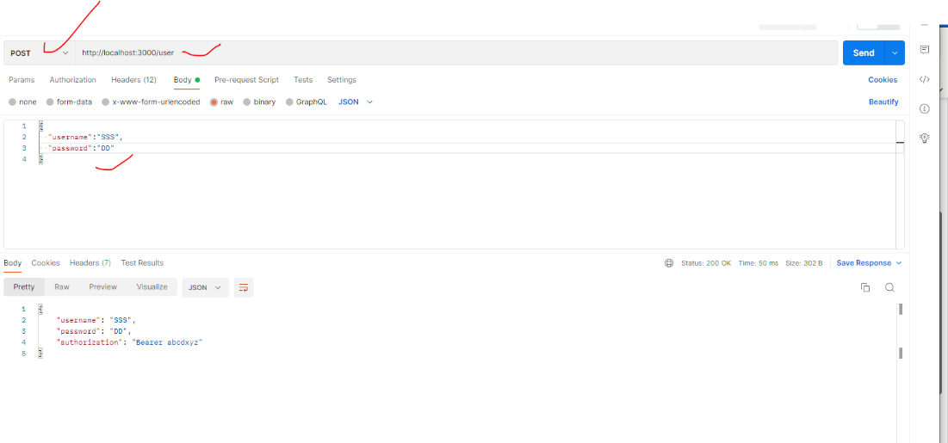

# ***app.put() Function:***

*The****app.put() function****routes the HTTP PUT requests to the specified path with the specified callback functions.*

***Syntax:***

*app.put(path, callback [, callback ...])*

***Arguments:***

1. ***Path:****The path for which the middleware function is invoked and can be any of:*
   * *A string representing a path.*
   * *A path pattern.*
   * *A regular expression pattern to match paths.*
   * *An array of combinations of any of the above.*
2. ***Callback:****Callback functions can be:*
   * *A middleware function.*
   * *A series of middleware functions (separated by commas).*
   * *An array of middleware functions.*
   * *A combination of all of the above.*

***Installation of express module:***

1. *You can visit the link to*[*Install express module*](https://www.npmjs.com/package/express)*. You can install this package by using this command.*

*npm install express*

1. *After that, you can just create a folder and add a file for example, index.js. To run this file you need to run the following command.*

*node node server.js*

*More info:* [*https://www.geeksforgeeks.org/express-js-app-put-function/*](https://www.geeksforgeeks.org/express-js-app-put-function/)

# ***Code:***

//************PUT*************** */

app.put('/putuserdata:', (req, res) => {

  res.send("PUT Request Called")

})

### *Output:*

PUT: http://localhost:3000/putuserdata

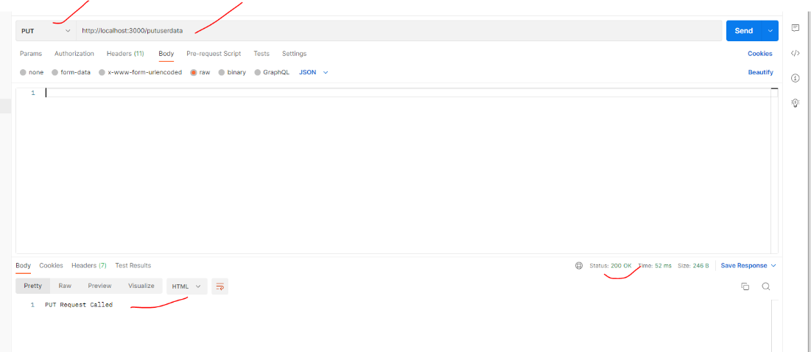

# ***app.delete() Function:***

The **app.delete()** function is used to route the HTTP DELETE requests to the path which is specified as parameter with the callback functions being passed as parameter.  
**Syntax:** 

app.delete(path, callback)

**Parameters:** 

1. **path:** It is the path for which the middleware function is being called.
2. **callback:** It is a middleware function or a series/array of middleware functions.

**Installation of express module:** 

1. You can visit the link to [Install express module](https://www.npmjs.com/package/express). You can install this package by using this command.

npm install express

2.After that, you can just create a folder and add a file for example, index.js. To run this file you need to run the following command. 

node server.js

*More info:* [*https://www.geeksforgeeks.org/express-js-app-delete-function/*](https://www.geeksforgeeks.org/express-js-app-delete-function/)

*Code*:

//************PUT*************** */

app.put('/putuserdata:', (req, res) => {

  res.send("PUT Request Called")

})

### *Output:*

DELETE:

http://localhost:3000/user/1

